VISVESVARAYA TECHNOLOGICAL UNIVERSITY
"Jnana Sangama", Belgavi-590 018, Karnataka, India



A MINIPROJECT REPORT
On
TRAFFIC SIGNAL VIOLATION DETECTION
Submitted in Partial Fulfillment of the requirement for the award of the degree of

BACHELOR OF ENGINEERING
IN
ARTIFICIAL INTELLIGENCE & MACHINE LEARNING

Submitted By
K UJWAL REDDY 1MV22AI026 PRAJWAL 1MV22AI037
PRAVEEN A BILGUN 1MV22AI039
PUNITH K V 1MV22AI045
Carried out at
Department of AIML,
Sir M. Visvesvaraya Institute of Technology

Under the guidance of
Dr. S AMBAREESH
Assistant Professor
Dept. Of AIML
Sir MVIT


SIR M. VISVESVARAYA INSTITUTE OF TECHNOLOGY
DEPARTMENT OF ARTIFICIAL INTELLIGENCE & MACHINE LEARNING
BENGALURU-562157
2024-2025

SIR M. VISVESVARAYA INSTITUTE OF TECHNOLOGY
Bengaluru - 562157
Department of Artificial Intelligence & Machine Learning

CERTIFICATE
This is to certify that the project work entitled “Traffic Signal Violation Detection” is a bonified work carried out by K UJWAL REDDY (1MV22AI026), PRAJWAL B (1MV22AI037), PRAVEEN A BILGUNDI(1MV22AI039), PUNITH K V (1MV22AI045) in partial fulfilment for the 5th semester of Bachelor of Engineering in Artificial Intelligence & Machine Learning of Visvesvaraya Technological University, Belagavi during the year 2024-2025. It is certified that all corrections/suggestions indicated for internal assessment have been incorporated in the report. The project report has been approved as it satisfies the academic requirements with respect to project work prescribed for the Bachelor of Engineering degree.

.................................  Signature of Guide  Dr. S AMBAREESH  Designation  Dept. of AIML, SMVIT | ...................................  Signature of HOD  Dr. Soumya Patil  Assoc. Prof. & HOD,  Dept. of AIML, SMVIT | ..................................  Signature of Principal  Prof. Rakesh S G  Principal SMVIT,  Bengaluru

External Examiners:
Name of the Examiners Signature with Date

1.
2.

DECLARATION

We K UJWAL REDDY, PRAJWAL B, PRAVEEN A BILGUNDI,
PUNITH K V Student of V semester B.E in Artificial Intelligence &
Machine Learning at Sir M. Visvesvaraya Institute of Technology,
Bengaluru, hereby declare that this dissertation work entitled “Traffic
Signal Violation Detection” has been carried out at Dept. of AIML,
Sir M. Visvesvaraya Institute of Technology under the guidance of guide
Dr. S AMBAREESH, Assistant Professor, Dept. of AIML,
Sir M. Visvesvaraya Institute of Technology, Bengaluru and submitted
in the partial fulfilment for the 5th semester of Bachelor of Engineering in
Artificial Intelligence & Machine Learning of Visvesvaraya Technological
University, Belagavi during the academic year 2024-2025. We further
declare that the report had not been submitted to any other university for
the award of any other degree.

Place: Bengaluru STUDENT NAME’S USN:
Date:
K UJWAL REDDY 1MV22AI026
PRAJWAL B 1MV22AI037
PRAVEEN A BILGUNDI 1MV22AI039
PUNITH K V 1MV22AI045

CONTENTS

  - ABSTRACT
  - INTRODUCTION
  - LITERATURE SURVEY
  - PROBLEM STATEMENT
  - SIGNIFICANCE & RELEVANCE OF WORK
  - OBJECTIVES AND METHODOLOGY
  - SRS
  - CONCLUSION
  - REFERENCES

ABSTRACT

Now-a-days traffic violations are increased which causes road accidents. The increase in traffic rule violation increases the accidents. In order to reduce traffic violations and road accidents, we are using traffic violation detection systems. In this paper, we propose a system to monitor the vehicle movement and track the vehicle involved in traffic violations such as signal violation, speeding and accidents.

The proposed system enhances the traffic rules by detecting signal violation and alerting the vehicle owner about it and detection of speed and if the limit is exceeded then an automatic message about the details of the vehicle will be sent to the nearby control room in order to prevent hit and run accidents.

The proposed system is to catch instances of breaking traffic rules, like jumping signals or crossing the center line. This work utilizes You Only Look Once (YOLOv3), renowned for its ability to process data in real time, to boost the precision of detection. The positive outcomes on public safety are delved into, underscoring the ability to mitigate the risk of accidents. This implementation achieved a vehicle count detection accuracy of 98.76%.

It also includes a webpage to control and keep records of violations which makes it easier for Traffic police to track and maintain records in order to regulate traffic accordingly in accident prone areas.

INTRODUCTION

- Traffic Violation Detection Systems (TVDS) are undergoing development to cope with the escalating number of vehicles on the roads. The surge in traffic violations poses a challenge for trigger-based traffic violation detection systems, which struggle to keep pace with the high traffic volume and are not designed to detect multiple violations simultaneously for a given vehicle. Therefore, there is a pressing need for a TVDS capable of addressing this task, identifying criminal traffic offenses such as signal jumping. The initial method of traffic monitoring involved human traffic police officers stationed at every junction, necessitating human resources and continuous presence. This work is centred on the development of a traffic violation detection system using YOLOv3. In the contemporary world, the rapid increase in the number of vehicles makes traffic management an arduous task, even with the presence of traffic police. In response to these challenges, an automated system, TVDS, has been proposed. This system utilizes cameras connected to traffic signals to monitor and detect violations. It begins by capturing the vehicle, if a violation is detected, an automated email module sends a message to the vehicle owner, specifying the location of the violation.

- The novel contribution of this proposed work aims to address these challenges and provide an automated traffic signal violation detection using YOLOv3 algorithm. Automation has become integral to daily life, and addressing traffic rule violations is crucial in reducing accidents. Common violations such as disregarding traffic signals, speeding, driving on the wrong side, and not yielding to pedestrians contribute to road accidents. Our system aims to utilize high surveillance systems, integrating them with Deep Learning to identify violations. This approach eliminates human errors and limitations, offering a real-time identification system vital for safety and societal well-being. Traffic rules play a pivotal role in preventing accidents and ensuring efficient traffic flow. Implementing an automated traffic violation detection system enhances the effectiveness of these rules, creating a safer environment for drivers and pedestrians alike.

- YOLOv3 is a real-time object detection algorithm for computer vision applications. YOLOv3 is a state-of-the-art deep-learning model that excels in accurately identifying and localizing objects within images with remarkable speed. Its key innovation lies in its ability to divide an image into a grid and predict bounding boxes and class probabilities simultaneously, allowing for rapid and efficient detection. YOLOv3 incorporates a hierarchical feature extraction approach, enabling it to capture intricate spatial relationships and contextual information, leading to superior detection performance. Positioned as a pivotal solution in object detection, YOLOv3 stands out for its commitment to speed, accuracy, and versatility.

LITERATURE SURVEY

Optimizing Traffic Flow and Pedestrian Safety: The Role of Crosswalk Distance in Roundabout Design (2024)
Authors: A. Charef, Z. Jarir, and M. Quafafou.
This study examines how crosswalk placement relative to roundabouts impacts both traffic efficiency and pedestrian safety. The authors emphasize the need for strategic crosswalk positioning to minimize disruptions to vehicle flow while ensuring pedestrian access and safety. By optimizing crosswalk distances from the roundabout, the research highlights an indirect approach to reducing traffic signal violations and enhancing overall compliance with traffic rules. The study's findings are particularly relevant for urban planners aiming to design safer and more efficient intersections.

Smart System for Emergency Traffic Recommendations : Urban Ambulance Mobility (2023)
Authors: A. Charef, Z. Jarir, and M. Quafafou,.
This study focuses on developing a smart traffic management system to optimize urban ambulance mobility during emergencies. The proposed system utilizes advanced algorithms and real-time traffic data to recommend optimal routes for ambulances, ensuring minimal delays and improved response times. The research highlights the importance of integrating smart city infrastructure with IoT devices and traffic sensors to dynamically manage traffic conditions. By prioritizing ambulance movement, the system aims to enhance urban emergency response efficiency while reducing the risks associated with delayed medical assistance.

Identification of Motorcycle Traffic Violations with Deep Learning Method (2022)
Authors: R. Ferdian and T. P. Sari,
This research explores the application of deep learning techniques to detect and identify traffic violations committed by motorcyclists. The study employs advanced computer vision algorithms, such as Convolutional Neural Networks (CNNs), to process images and videos captured from surveillance cameras. Key violations analyzed include riding without helmets, exceeding speed limits, and improper lane usage. The system demonstrated high accuracy in recognizing motorcycles and categorizing their behaviors as compliant or non-compliant. The authors emphasize the importance of automated systems in improving enforcement efficiency and road safety, particularly in regions with high motorcycle traffic density.

Traffic Rule Violation Detection System using Surveillance Videos in Real-Time (2021)
Authors: D. A. Naik, P. Naik, and S. O. Reddy
This study presents a real-time traffic rule violation detection system leveraging surveillance video data. The authors utilize computer vision techniques to process live video streams and detect violations such as signal jumping, improper lane usage, and overspeeding. The system integrates object detection and tracking algorithms, such as YOLO (You Only Look Once) and Kalman filters, to identify vehicles and monitor their compliance with traffic rules. The proposed solution is designed to provide immediate alerts to authorities and enable automated penalization. The study emphasizes the system's scalability and potential to reduce manual monitoring efforts while improving road safety and rule adherence.

Real-Time Traffic Signal Violation using Artificial Intelligence and Machine Learning (2022)
Authors: Ajit Chaurasiya, Atul Kumar Jha, Dibyanshu Jha, Jitendra Kumar Yadav, Imran Ulla Khan
This study focuses on leveraging artificial intelligence (AI) and machine learning (ML) to detect traffic signal violations in real-time. The proposed system integrates video surveillance with AI-powered algorithms to identify and track vehicles violating red lights or other traffic regulations. Key components include object detection models, such as YOLO or SSD, and machine learning classifiers to analyze vehicle behavior. The system automates the process of capturing violations and recording details like license plate numbers, improving enforcement efficiency. The authors emphasize the scalability of their approach and its potential to significantly enhance road safety by reducing human dependency in traffic monitoring and enforcement.

Real-Time Object Detection Based on YOLOv3 Using Python (2023)
J. Malla Reddy, M. Harsha Vardhan, M. Kamal Nadh, N. Priyanka (2023), “Real-Time Object Detection Based on YOLOv3 Using Python”
This study highlights the implementation of a real-time object detection system using YOLOv3, a state-of-the-art deep learning algorithm, written in Python. The system is designed for dynamic environments and excels in detecting multiple objects simultaneously with high speed and accuracy. The research emphasizes its application in traffic monitoring, where YOLOv3 can identify vehicles, pedestrians, and other objects in real time, making it a suitable tool for tasks like traffic signal violation detection. The authors demonstrate the efficiency of YOLOv3 in processing complex traffic scenarios, showcasing its potential for smart city applications and enhanced traffic management systems.

Real Time Traffic Signal Violation using Artificial Intelligence and Machine Learning (2022)
Authors : Ajit Chaurasiya, Atul Kumar Jha, Dibyanshu Jha, Jitendra Kumar Yadav, Imran Ulla Khan.
The paper "Real Time Traffic Signal Violation using Artificial Intelligence and Machine Learning" (2022) by Ajit Chaurasiya et al. proposes a system to detect traffic signal violations in real time using AI and machine learning. By utilizing computer vision and machine learning algorithms like Convolutional Neural Networks (CNNs), the system analyzes video footage to monitor vehicle movements and determine if they violate traffic signals. The proposed solution aims to enhance traffic safety, reduce human error, and improve traffic management efficiency by providing automated violation detection and real-time alerts to authorities.

Traffic Signal Violation Detection using Artificial Intelligence and Deep Learning
Authors : Franklin, R. J. (2020, June)
In 2020 The paper "Traffic Signal Violation Detection using Artificial Intelligence and Deep Learning" (2020) by R. J. Franklin proposes a system that uses deep learning, specifically Convolutional Neural Networks (CNNs), to detect traffic signal violations in real time. By analyzing video footage from traffic cameras, the system identifies when vehicles run red lights or violate traffic signals. This automated approach improves traffic safety, reduces human error, and enhances enforcement efficiency, offering a promising solution for smart city traffic management.

S-tvds: Smart traffic violation detection system for Indian traffic scenario (2019)
Authors : Kumar, A., Kundu, S., Kumar, S., Tiwari, U. K., & Kalra, J.
It presents a system designed to detect traffic violations in India using computer vision, machine learning, and sensors. The S-tvds system monitors traffic in real time, automatically detecting violations such as running red lights. It addresses the challenges of Indian traffic by integrating with existing infrastructure to improve traffic management, reduce violations, and enhance road safety.

High-Security Registration Plate Detection using OpenCV and Python (2022)
Authors: M. Kumar, S. Singh, U. Pilania and A. Aggarwal
It presents an automated system for detecting vehicle registration plates using OpenCV and Python. The system processes images to locate and extract alphanumeric characters from number plates, ensuring high accuracy in various conditions. It is designed for high-security applications, such as toll plazas and law enforcement, providing a reliable and efficient solution for vehicle identification and tracking.

PROBLEM STATEMENT

In urban areas, traffic signal violations are a significant concern, contributing to accidents, congestion, and a lack of road discipline. The objective is to develop an intelligent and automated system for detecting traffic signal violations using the YOLOv3 object detection algorithm.
This system should identify vehicles that cross intersections when the traffic light is red and capture evidence for enforcement purposes. It should be capable of processing live video feeds or recorded footage to detect the following:
- Traffic Signal State Detection: Accurately identify the state of the traffic signal (red, yellow, green).
- Vehicle Detection and Tracking: Detect and track vehicles approaching and crossing the intersection.
- Violation Identification: Determine if a vehicle crosses the intersection during a red light.
- Evidence Collection: Capture and save images or video snippets of the violation along with relevant metadata (e.g., timestamp, vehicle details).
The solution must handle varying lighting conditions, weather, and occlusions while maintaining high accuracy and real-time performance. The ultimate goal is to assist traffic authorities in monitoring compliance, improving road safety, and reducing traffic signal violations.

SIGNIFICANCE & RELEVANCE OF WORK
Significance and Relevance of Traffic Signal Violation Detection using YOLOv3:
- Real-time Monitoring:
YOLOv3's ability to detect objects in real-time ensures effective monitoring of traffic signals, allowing violations to be detected as they occur.
- Enhanced Road Safety:
By identifying vehicles that violate traffic signals, authorities can take corrective actions to reduce accidents and improve overall road safety.
- Automated Violation Detection:
The system eliminates the need for manual monitoring by automating the detection of traffic violations, saving time and resources.
- Scalability:
YOLOv3 can process high volumes of data, making it suitable for large-scale deployments in cities with heavy traffic.
- Accuracy:
YOLOv3's object detection precision ensures that vehicles are accurately identified, minimizing false positives and false negatives in violation reports.
- Cost-effective Solution:
Using YOLOv3 in combination with existing CCTV infrastructure provides a cost-effective way to enforce traffic rules without additional hardware.
- Data Analytics:
The system can gather and analyse data on traffic violations, helping authorities identify patterns and design better traffic management policies.
- Support for Legal Action:
Capturing video evidence of traffic violations provides strong proof to enforce fines or penalties, ensuring compliance with traffic laws.
- Environment-friendly Impact:
Reduced signal violations lead to smoother traffic flow, which in turn minimizes vehicle idling and contributes to lower emissions.
- Public Awareness:
The presence of such advanced technology creates awareness among drivers, encouraging adherence to traffic rules.

OBJECTIVES AND METHODOLOGY

- Automated Detection of Traffic Violations
  - Objective: Create a system capable of detecting vehicles that violate traffic signals in real-time.
  - Methodology: Utilize the YOLOv3 object detection algorithm to identify vehicles and their movement patterns in relation to traffic lights and stop lines in video frames. Train the system to differentiate between legal and illegal movements based on traffic signal status.
- Improved Traffic Management
  - Objective: Enhance the ability of traffic authorities to manage and monitor intersections effectively by identifying violators automatically.
  - Methodology: Develop an integrated system that analyses video feeds from traffic cameras and flags violations, reducing manual intervention and enabling smoother traffic flow.
- Accurate Localization
  - Objective: Accurately detect and localize vehicles that cross stop lines during red signals.
  - Methodology: Use YOLOv3’s bounding box predictions to pinpoint vehicle positions in each frame and cross-reference these positions with predefined stop-line locations and signal statuses.
- Scalability
  - Objective: Ensure the solution can handle diverse traffic environments, such as varying lighting and weather conditions.
  - Methodology: Train the YOLOv3 model on a diverse dataset covering different times of the day, weather scenarios, and traffic densities to improve its robustness across multiple environments.
- Evidence Capture
  - Objective: Provide clear visual evidence of violations for administrative or legal purposes.
  - Methodology: Implement a system to save snapshots or video clips of violations, showing the vehicle's position, the stop line, and the signal status at the time of the violation.
- Real-Time Processing
  - Objective: Detect and report violations in real-time to enable immediate action by authorities.
  - Methodology: Optimize the YOLOv3 model for faster inference speeds and integrate it with a real-time video processing pipeline for prompt detection and reporting.
- Performance Analysis and Refinement
  - Objective: Evaluate and improve the system’s accuracy and reliability over time.
  - Methodology: Test the system under various real-world scenarios, analyse the false positive and negative rates, and fine-tune the YOLOv3 model and violation detection logic based on performance metrics.

METHODOLOGY

- Data Collection and Preparation
- Collect video data from traffic surveillance cameras at intersections.
- Label the dataset to identify vehicles, traffic signals, and stop lines for training purposes.
- Preprocess the dataset to standardize resolution, format, and brightness levels.
- Model Training
- Train the YOLOv3 (You Only Look Once version 3) object detection model on the prepared dataset.
- Include classes for vehicles (cars, bikes, buses, etc.) and traffic signals (red, green, yellow).
- Ensure the training covers diverse lighting, weather, and traffic conditions for robustness.
- Traffic Signal Detection
  - Implement a separate module to detect the state of traffic signals (red, green, yellow) in real-time.
  - Integrate the YOLOv3 model to classify the signal status from each video frame.
- Vehicle Tracking
  - Use YOLOv3’s bounding boxes to detect and track vehicles across video frames.
  - Map the detected vehicles’ positions with the predefined stop-line locations in the video.
- Violation Detection Logic
  - Define the rules for identifying a violation, e.g., a vehicle crossing the stop line during a red light.
  - Compare the vehicle’s position with the stop line and signal status to flag violations.
  - Implement a system to ignore vehicles moving legally during green signals or before the red signal is active.
- Real-Time Inference
  - Integrate the trained YOLOv3 model with a real-time video processing pipeline.
  - Ensure low-latency inference to detect and report violations as they occur.
- Evidence Capture
  - Save snapshots or short video clips of flagged violations for use by traffic authorities.
  - Include annotations showing the vehicle, stop line, and traffic signal status in the evidence.
- System Optimization
  - Use hardware acceleration (e.g., GPUs) for faster detection and tracking.
  - Optimize the YOLOv3 model’s performance for better speed and accuracy in real-world scenarios.
- Testing and Validation
  - Test the system on live traffic intersections to evaluate its effectiveness.
  - Analyse false positives (incorrect violations) and false negatives (missed violations) to refine the model and detection logic.
- Deployment and Monitoring
- Deploy the system in real-world traffic intersections.
- Continuously monitor its performance and retrain the model periodically with new data to adapt to changing scenarios.

WORKFLOW :
Here is a workflow diagram representing the process of traffic signal violation detection using YOLOv3. Each step in the workflow outlines the data preparation, training, detection, and deployment processes. Let me know if you'd like any modifications
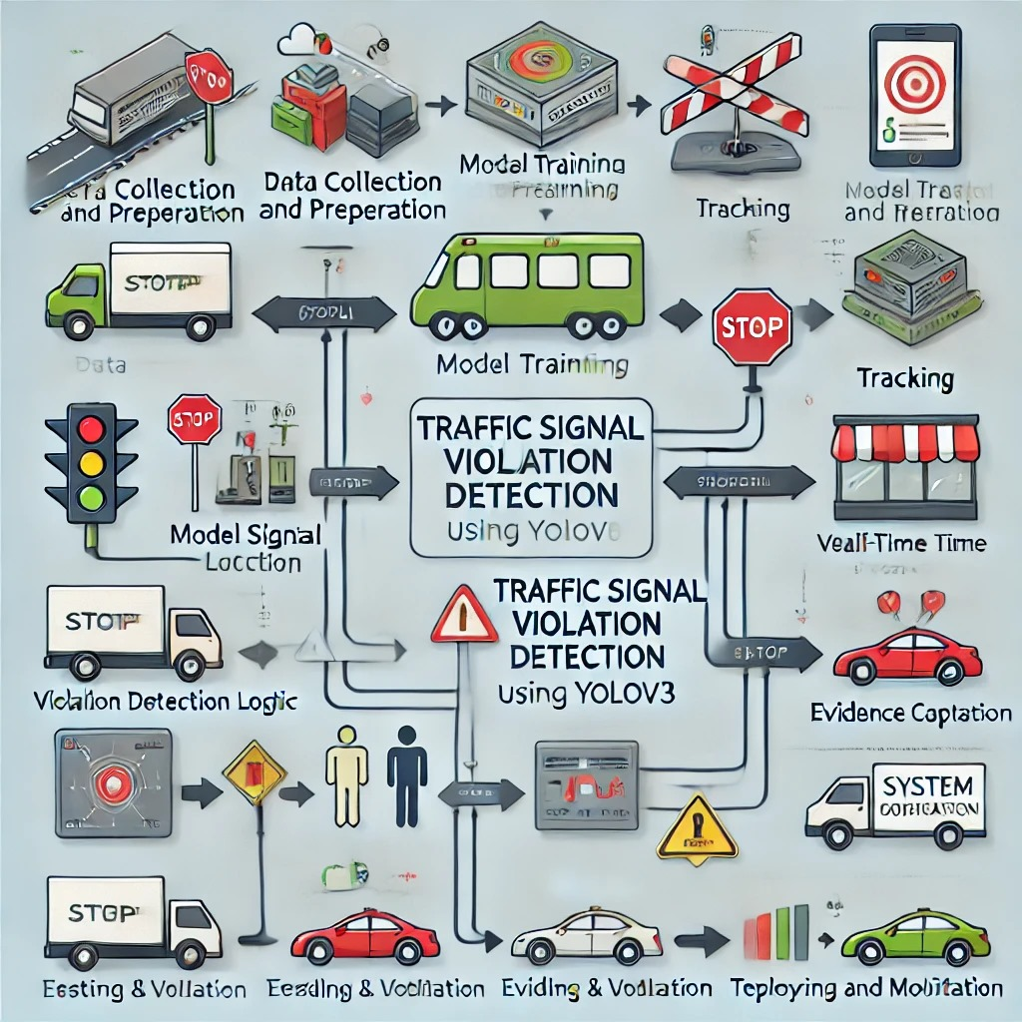

SRS (System Requirement Specifications) for Traffic Signal Violation Detection using YOLOv3

Hardware Requirements:
- Processor: Minimum Quad-core CPU (Recommended: GPU for YOLOv3).
- Memory (RAM): At least 8GB of RAM (Recommended: 16GB or more).
- Storage: 100GB or more to store datasets, logs, and processed data.
- GPU: Dedicated GPU with at least 8GB of VRAM (e.g., NVIDIA GTX 1080 or better).
- Camera Hardware: High-definition surveillance cameras with a minimum resolution of 1080p.

Software Requirements:
- Operating System:
  - Windows 10/11
  - macOS (Latest Version)
  - Linux (Ubuntu 20.04 or later, recommended for server deployments).
- Programming Language:
  - Python (Version 3.7 or later).
- Integrated Development Environment (IDE):
  - Jupyter Notebook
  - Visual Studio Code
- Machine Learning Libraries:
  - TensorFlow: For deep learning tasks.
  - PyTorch: Optional alternative for YOLO-based operations.
  - OpenCV: For image processing and real-time video analysis.
  - Pandas: For data manipulation.

  - NumPy: For numerical computations.
  - Seaborn/Matplotlib: For visualization of results.
- Natural Language Processing Tools (if needed):
  - Transformers: For additional contextual understanding of text-based annotations (optional).
  - CNN: For image classification tasks related to traffic signals.
- YOLO Framework:
  - Pre-trained YOLOv3 weights and configuration files.
- Data Manipulation and Visualization Tools:
  - Pandas: For managing structured data like logs of violations.
  - Matplotlib/Seaborn: For generating charts/graphs for analysis.
  - Streamlit: For creating a web interface to visualize detection results.
- Other Required Libraries:
  - Python-Dotenv: For handling environment variables.
  - Google GenAI and OpenAI Libraries: For advanced prediction or modeling (if required).
  - Scikit-learn: For any additional machine learning tasks.
- Web Application Framework (Optional):
  - Streamlit or Flask: For creating a user-friendly web interface for monitoring and reporting.
- Database (Optional):
- SQLite or MySQL for storing logs of violations.

These requirements are specifically tailored to handle real-time traffic signal violation detection using YOLOv3, ensuring efficient processing and accurate results. Let me know if you need elaboration or adjustments.
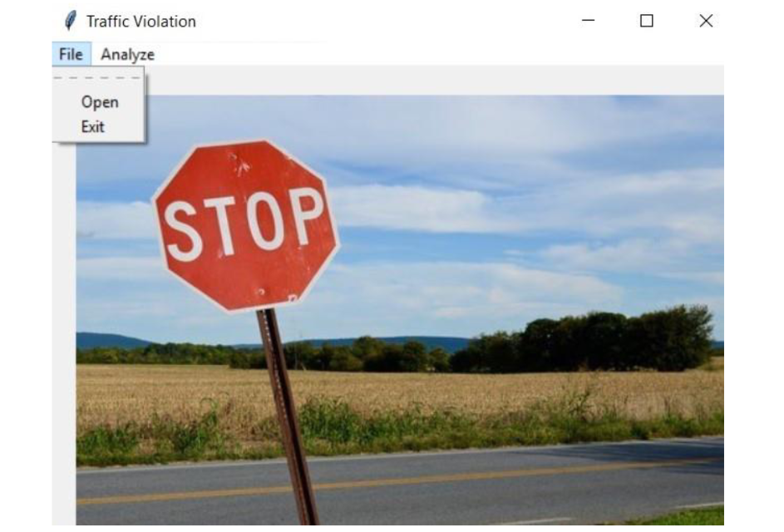

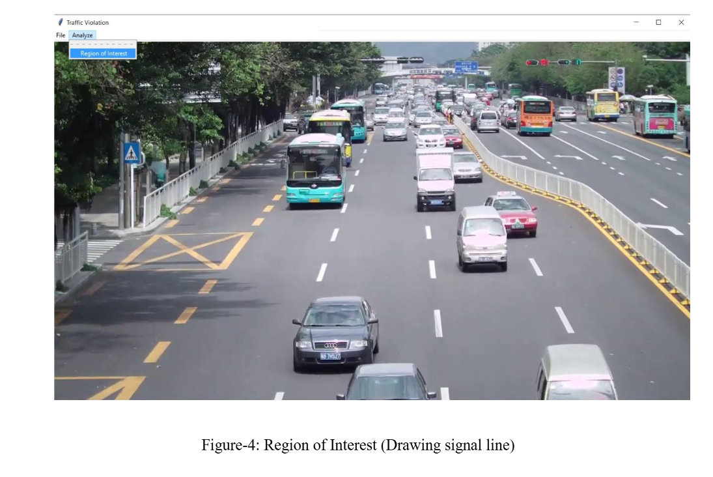

CONCLUSION

The traditional method of identifying traffic violations relies on manual efforts from traffic police who capture images of individuals surpassing predefined traffic boundaries. However, this approach has limitations, particularly in its inability to efficiently detect and capture multiple violations simultaneously. In response, a proposed algorithm has showcased superior speed and effectiveness compared to human counterparts, particularly in pinpointing violations related to traffic signals. The current system's drawback lies in processing one piece of data at a time, leading to a slower runtime, emphasizing the necessity for a high-speed processing system. Future research endeavours aim to expand the algorithm's capabilities by incorporating additional high-level image processing techniques. This expansion is anticipated to enhance runtime efficiency by filtering out irrelevant information. The project's future scope involves the integration of advanced technologies like YOLOv4 and CNNs (Convolutional Neural Networks) to refine the object detection model for more effective traffic violation detection.

REFERNCES

[1] Pattanashetty, V. B., Mane, V., Iyer, N. C., & Kore, S. (2022). Traffic rules violation detection system. In Information and Communication Technology for Competitive Strategies (ICTCS 2020) ICT: Applications and Social Interfaces (pp. 77-87). Springer Singapore.
[2] S. Raj Anand, Naveen Kilari and D. Udaya Suriya Raj Kumar, Traffic Signal Violation Detection using Artificial Intelligence and Deep Learning, International Journal of Advanced Research in Engineering and Technology (IJARET) ,12(2), 2021, pp. 207 217.
[3] Rong Guo, Shixin Li, Kun Wang, Research on YOLOv3 algorithm based on darknet framework, 2020 J. Phys.: Conf. Ser. 1629 012062.
[4] H. Jang, H.-J. Yang, D.-S. Jeong and H. Lee, "Object classification using CNN for video traffic detection system," 2015 21st Korea-Japan Joint Workshop on Frontiers of Computer Vision (FCV), Mokpo, Korea (South), 2015, pp. 1-4, doi: 10.1109/FCV.2015.7103755.
[5] P. Sridhar, M. Jagadeeswari, S. H. Sri, N. Akshaya and J. Haritha, "Helmet Violation Detection using YOLO v2 Deep Learning Framework," 2022 6th International Conference on Trends in Electronics and Informatics (ICOEI), Tirunelveli, India, 2022, pp. 1207-1212, doi: 10.1109/ICOEI53556.2022.9776661.
[6] J. Malla Reddy, M. Harsha Vardhan, M. Kamal Nadh, N. Priyanka, 2023, Real-Time Object Detection based on YOLOv3 using Python, INTERNATIONAL JOURNAL OF ENGINEERING RESEARCH & TECHNOLOGY (IJERT) Volume 12, Issue 07 (July 2023)
[7] Ajit Chaurasiya, Atul Kumar Jha, Dibyanshu Jha, Jitendra Kumar Yadav, Imran Ulla Khan, 2022, Real Time Traffic Signal Violation using Artificial Intelligence and Machine Learning, INTERNATIONAL JOURNAL OF ENGINEERING RESEARCH & TECHNOLOGY (IJERT) RTCSIT– 2022 (Volume 10– Issue 12).

[8] Franklin, R. J. (2020, June). Traffic Signal Violation Detection using Artificial Intelligence and Deep Learning. In 2020 5th International Conference on Communication and Electronics Systems (ICCES) (pp. 839-844). IEEE.
[9] Kumar, A., Kundu, S., Kumar, S., Tiwari, U. K., & Kalra, J. (2019). S-tvds: Smart traffic violation detection system for Indian traffic scenario. International Journal of Innovative Technology and Exploring Engineering (IJITEE), 8(4S3), 6-10.

[10] M. Kumar, S. Singh, U. Pilania and A. Aggarwal, "High-Security Registration Plate Detection using OpenCV and Python," 2022 7th International Conference on Communication and Electronics Systems (ICCES), Coimbatore, India, 2022, pp. 835-839, doi: 10.1109/ICCES54183.2022.9835830.
[11] Day, C. M., Li, H., Richardson, L. M., Howard, J., Platte, T., Sturdevant, J. R., & Bullock, D. M. (2017). Detector-free optimization of traffic signal offsets with connected vehicle data. Transportation Research Record, 2620(1), 54-68.
[12] Aladin, D. V., Varlamov, O. O., Chuvikov, D. A., Chernenkiy, V. M., Smelkova, E. A., & Baldin, A. V. (2019, May). Logic based artificial intelligence in systems for monitoring the enforcing traffic regulations.
[13] A. Charef, Z. Jarir, and M. Quafafou, “Optimizing Traffic Flow and Pedestrian Safety: The Role of Crosswalk Distance in Roundabout Design,” 2024 International Conference on Global Aeronautical Engineering and Satellite Technology (GAST), pp. 1–6, Apr. 2024, doi: 10.1109/GAST60528.2024.10520741.
[14] R. George, Pikala Bikes, Marrakesh, Morocco: a social entrepreneurship company. Edward Elgar Publishing, 2024. Accessed: Feb. 15, 2024. [Online]. Available: https://www.elgaronline.com/edcollchap/book/9781803923857/boo k-part-9781803923857-20.xml
[15] A. Charef, Z. Jarir, and M. Quafafou, “Smart System for Emergency Traffic Recommendations : Urban Ambulance Mobility,” IJACSA) International Journal of Advanced Computer Science and Applications, vol. 13, no. 10, p. 2022, Accessed: Dec. 19, 2023. DOI: 10.14569/IJACSA.2022.0131005
[16] R. Ferdian and T. P. Sari, “Identification of Motorcycle Traffic Violations with Deep Learning Method,” Proceeding - 2022 International Symposium on Information Technology and Digital Innovation: Technology Innovation During Pandemic, ISITDI 2022, pp. 146–149, 2022, doi: 10.1109/ISITDI55734.2022.9944502.
[17] A. Afzal, H. U. Draz, M. Z. Khan, and M. U. G. Khan, “Automatic Helmet Violation Detection of Motorcyclists from Surveillance Videos using Deep Learning Approaches of Computer Vision,” 2021 International Conference on Artificial Intelligence, ICAI 2021, pp. 252–257, Apr. 2021, doi: 10.1109/ICAI52203.2021.9445206.
[18] A. Goyal, D. Agarwal, A. Subramanian, C. V. Jawahar, R. K. Sarvadevabhatla, and R. Saluja, “Detecting, Tracking and Counting Motorcycle Rider Traffic Violations on Unconstrained Roads.” pp. 4303–4312, 2022. Accessed: Feb. 15, 2024. [Online]. Available: https://github.com/iHubData-Mobility/public-motorcycle violations
[19] M. M. Bachtiar, A. R. Mawardi, and A. R. A. Besari, “Vehicle Classification and Violation Detection on Traffic Light Area using BLOB and Mean-Shift Tracking Method,” 3rd International Conference on Applied Science and Technology, iCAST 2020, pp. 94–98, 2020, doi: 10.1109/ICAST51016.2020.9557628.
[20] M. M. Bachtiar, A. R. Mawardi, and A. R. A. Besari, “Vehicle Classification and Violation Detection on Traffic Light Area using BLOB and Mean-Shift Tracking Method,” 3rd International Conference on Applied Science and Technology, iCAST 2020, pp. 94–98, 2020, doi: 10.1109/ICAST51016.2020.9557628.
[21] A. Charef, Z. Jarir, and M. Quafafou, “The Impact of Motorcycle Positioning on Start-Up Lost Time: The Empirical Case Study of Signalized Intersections in Marrakech using VISSIM,” Engineering, Technology & Applied Science Research, vol. 14, no. 3, pp. 14313 14318, Jun. 2024, doi: 10.48084/ETASR.7141.
[22] D. A. Naik, P. Naik, and S. O. Reddy, “Traffic Rule Violation Detection System using Surveillance Videos in real-time,” Ann Rom Soc Cell Biol, vol. 25, no. 6, pp. 17865–17873, Jul. 2021, Accessed: Feb. 15, 2024. [Online]. Available: https://www.annalsofrscb.ro/index.php/journal/article/view/9150
[23] M. Dasgupta, O. Bandyopadhyay, and S. Chatterji, “Automated helmet detection for multiple motorcycle riders using CNN,” 2019 IEEE Conference on Information and Communication Technology, CICT 2019, Dec. 2019, doi: 10.1109/CICT48419.2019.9066191.
[24] T. Waris et al., “CNN-Based Automatic Helmet Violation Detection of Motorcyclists for an Intelligent Transportation System,” Math Probl Eng, vol. 2022, 2022, doi: 10.1155/2022/8246776.
[25] N.-N. Duong et al., “Robust Automatic Motorcycle Helmet Violation Detection for an Intelligent Transportation System.” pp. 5341–5349, 2023. [26] A. Charef, Z. Jarir, and M. Quafafou, “Assessing the driving behaviour of motorcyclists to improve road safety,” JUCS – Journal of Universal Computer Science 30(5): 617-644, vol. 30, no. 5, pp. 617–644, May 2024, doi: 10.3897/JUCS.108550..

